Single Linked List
Head
 |  |  |  | 300 |  |  |  | 100 |  |  | 200
 |  |  | 1 |  | 100 |  | 2 | 200 |  | 3 |  | Null




Doubly Linked List
Head
 |  |  |  |  | 100 |  |  |  |  | 200 |  |  |  | 300
 |  |  | Null | 1 |  | 200 |  |  | 100 | 2 | 300 |  | 200 | 3 | Null




Circular Linked List

100

1 | 200

_{Pop} Stack
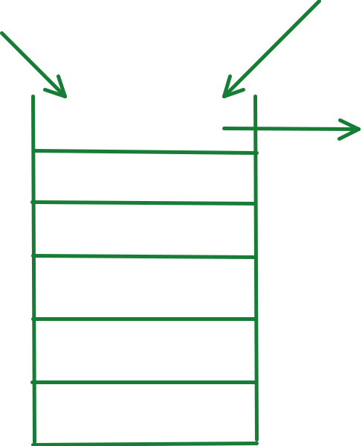

200

2 | 300

Push

Top

LIFO

300

3 100

Queue

Dequeue


Enqueue
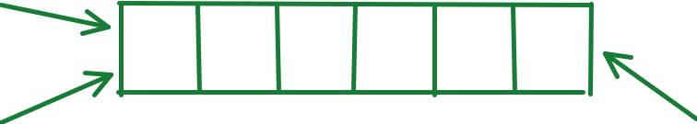

Rear Front

FIFO

Quick Notes Page 2

